Chairmans Report

John Kamau

11/07/2019

# Q_6.And are you the chairperson of the {0} VSLA?

|  |  |  |
| --- | --- | --- |
| Position | Mali | Uganda |
| Yes | 67 | 91 |
| No, chairperson isn’t available, so you have me (please specify position | 1 | 4 |
| Respondents | 68 | 95 |

# Q_8.Have you been with the group since the start?

|  |  |  |
| --- | --- | --- |
| Position | Mali | Uganda |
| Yes | 64 | 62 |
| No | 4 | 33 |
| Respondents | 68 | 95 |

# Q_10.When did you become the chairperson?

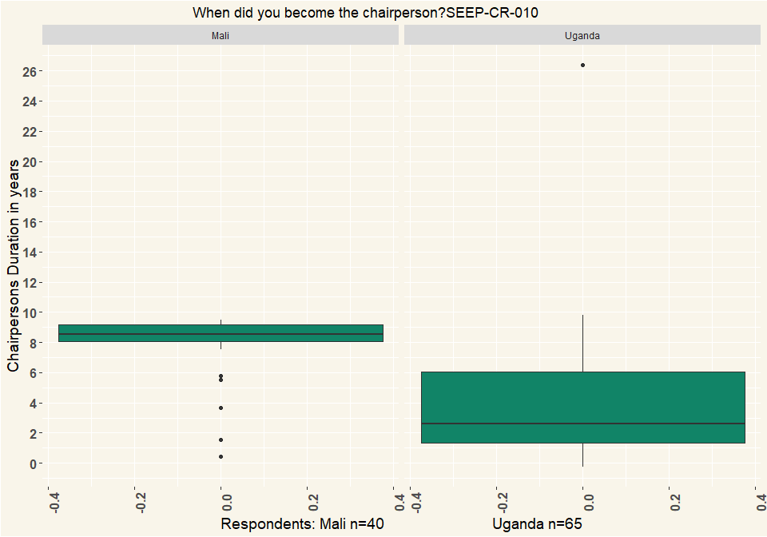

# Q_11.Have you been the chairperson continuously since that time?

|  |  |  |
| --- | --- | --- |
| Duration | Mali | Uganda |
| Yes, continuously | 57 | 62 |
| No, for a while someone else was chairperson | 10 | 33 |
| Other (specify) | 1 | NA |
| Respondents | 68 | 95 |

# Q12. How did you become chairperson?

|  |  |  |
| --- | --- | --- |
| Method | Mali | Uganda |
| I was elected with voting | 10 | 64 |
| We talked about it and we agreed I should be chairperson | 51 | 27 |
| I was appointed (e.g. by village leader, group trainer…) | 7 | 4 |
| Respondents | 68 | 95 |

# Q13. As chairperson, what are your duties? (Multiple Choice)

|  |  |  |
| --- | --- | --- |
| Duty | Mali | Uganda |
| Open or close the meetings | 59 | 66 |
| Oversee the meetings | 50 | 80 |
| Help the members stay disciplined | 39 | 59 |
| Decide the penalties that members pay | 35 | 27 |
| Resolve conflicts around repayment | 33 | 59 |
| Resolve other conflicts between members | 35 | 53 |
| Represent the group in the community | 35 | 48 |
| Train the group committee | 19 | 22 |
| Make sure the bookkeeping is correct | 10 | 28 |
| Train new members | 8 | 25 |
| It is an honorary or ceremonial post with no duties | 3 | 2 |
| Other( please specify) | 2 | 8 |
| Respondents | 68 | 95 |

# Q_14.Are there other members who could fulfill the post of chairperson, if you were not around?

|  |  |  |
| --- | --- | --- |
| Chairpersons_Replacement | Mali | Uganda |
| Yes, many | 47 | 20 |
| Yes, a few | 16 | 54 |
| I am training my replacement now | 1 | 6 |
| No, I am necessary | 3 | 2 |
| Does not want to answer | 1 | 13 |
| Respondents | 68 | 95 |

# Q21 Did the group already exist under some other form before it was trained as a VSLA?

|  |  |  |
| --- | --- | --- |
| Form | Mali | Uganda |
| Yes | 6 | 25 |
| No | 62 | 70 |
| Respondents | 68 | 95 |

# Q22 What happened to the group membership after you received training?

|  |  |  |
| --- | --- | --- |
| Membership | Mali | Uganda |
| Some members left | 12 | 53 |
| Membership stayed the same | 14 | 13 |
| New members joined | 36 | 63 |
| I don’t know | 7 | 5 |
| Does not want to answer | 1 | 3 |
| Respondents | 68 | 95 |

# Q_25.What organization did the trainer {0} work with?

|  |  |  |
| --- | --- | --- |
| Organization | Mali | Uganda |
| Approcel | NA | 14 |
| c’est un membre d’un autre groupe | 1 | NA |
| caeb | 10 | NA |
| care | NA | 17 |
| from diocese | NA | 3 |
| i can’t remember | NA | 1 |
| IDFA | NA | 9 |
| Iganga farmers association | NA | 7 |
| je ne sais pas | 1 | NA |
| JED | 8 | NA |
| jeunesse et développement | 3 | NA |
| OXFAM | 6 | NA |
| RECODE | NA | 8 |
| RUDIFA | NA | 2 |
| Sepsel | NA | 9 |
| UWESO | NA | 1 |
| village agent | NA | 1 |
| Respondents | 29 | 72 |

# Q_26.Did you ever support {0} with small gifts or money? (Multiple Choice)

|  |  |  |
| --- | --- | --- |
| Support | Mali | Uganda |
| Yes, regular payments of money for training | NA | 17 |
| yes. irregular payment of money | NA | 28 |
| yes. frequent gifts of food, airtime, clothes, etc. | NA | 5 |
| Yes, irregular gifts of food, airtime, clothes,etc. | 11 | 4 |
| Yes, money at share-out time | 57 | 29 |
| Other: | NA | 6 |
| No | NA | 17 |
| Don’t know | NA | 4 |
| Respondents | 68 | 95 |

# Q27. Thinking about the training you received, which of the following best describes it?

|  |  |  |
| --- | --- | --- |
| Training | Mali | Uganda |
| It was very good and we are independent | 24 | 45 |
| It was good but we still appreciate help | 31 | 35 |
| It was good but there are things we don’t know so we need help | 12 | 5 |
| It was lacking some things (describe) | 1 | NA |
| I don’t know | NA | 9 |
| Other (specify) | NA | 1 |
| Respondents | 68 | 95 |

# Q28. Does the group still receive visits from [NGO name]?

|  |  |  |
| --- | --- | --- |
| Visits | Mali | Uganda |
| Yes | 7 | 19 |
| No | 60 | 75 |
| I don’t know | 1 | 1 |
| Respondents | 68 | 95 |

# Q30.Have you or any members of your group ever trained any other group to help them form their own VSLA?

|  |  |  |
| --- | --- | --- |
| Trainings | Mali | Uganda |
| Yes | 8 | 29 |
| No | 60 | 66 |
| Respondents | 68 | 95 |

# Q34. In the past, has your group ever gotten so big that some members left to start a new group?

|  |  |  |
| --- | --- | --- |
| Size | Mali | Uganda |
| Yes | 3 | 12 |
| No | 65 | 74 |
| I don’t know | NA | 9 |
| Respondents | 68 | 95 |

# Q38. Do you think you yourself could train other people to form a new VSLA?

|  |  |  |
| --- | --- | --- |
| Trainings | Mali | Uganda |
| Yes | 27 | 76 |
| No | 41 | 19 |
| Respondents | 68 | 95 |

# Q41 Do you ever share new ideas with other groups?

|  |  |  |
| --- | --- | --- |
| Ideas | Mali | Uganda |
| Yes | 20 | 32 |
| No | 48 | 63 |
| Respondents | 68 | 95 |

# Q43. Have other groups ever shared new ideas with your group?

|  |  |  |
| --- | --- | --- |
| Ideas | Mali | Uganda |
| Yes | 17 | 17 |
| No | 51 | 78 |
| Respondents | 68 | 95 |

# Q45 FUNCTION: How does your group operate?

|  |  |  |
| --- | --- | --- |
| Operations | Mali | Uganda |
| The group retains savings from meeting to meeting with prime purpose to lend out and give savings back (DISTRIBUTING ASCA) | 53 | 77 |
| The group retains savings indefinitely and lends to members for investment, household expenses, or to pay for members’ emergencies such as funerals (NON DISTRIBUTING ASCA) | 14 | 2 |
| The group collects savings at every meeting, and gives all the collected funds to one member in turn, and the group retains no money from meeting to meeting (ROSCA) | NA | 2 |
| Other (specify) | 1 | 14 |
| Respondents | 68 | 95 |

# Q46. PURPOSE: What is the primary reason the group came together?

|  |  |  |
| --- | --- | --- |
| purpose | Mali | Uganda |
| Non-specific financial services | 6 | 49 |
| Farmers group | 1 | 6 |
| Social group | 37 | 15 |
| Funeral society | NA | 1 |
| Women’s group | 11 | 2 |
| Business group | NA | 10 |
| Other(specify) | 13 | 12 |
| Respondents | 68 | 95 |

# Q47 How does the group save?

|  |  |  |
| --- | --- | --- |
| Savings | Mali | Uganda |
| Each member saves exactly the same at every meeting during the cycle (but some members can save for 2 or 3 “mains”) | 46 | 6 |
| Each member saves the same at each meeting, but the amount fluctuates according to the economic situation (hunger months, we save less) (but some members can save for 2 or 3) | NA | 7 |
| Each member can decide each meeting what to save, but minimum of one share, and there is a maximum number of shares | 6 | 50 |
| Each member can decide each meeting, no minimum but a maximum number of shares | 1 | 8 |
| Each member can decide each meeting what to save, no minimum, no maximum | NA | 2 |
| Other (specify) | NA | 2 |
| I don’t want to answer | NA | 2 |
| Respondents | 53 | 77 |

# Q52 You said your group periodically “shares out” – distributes the group funds among the members. When did you last share-out?

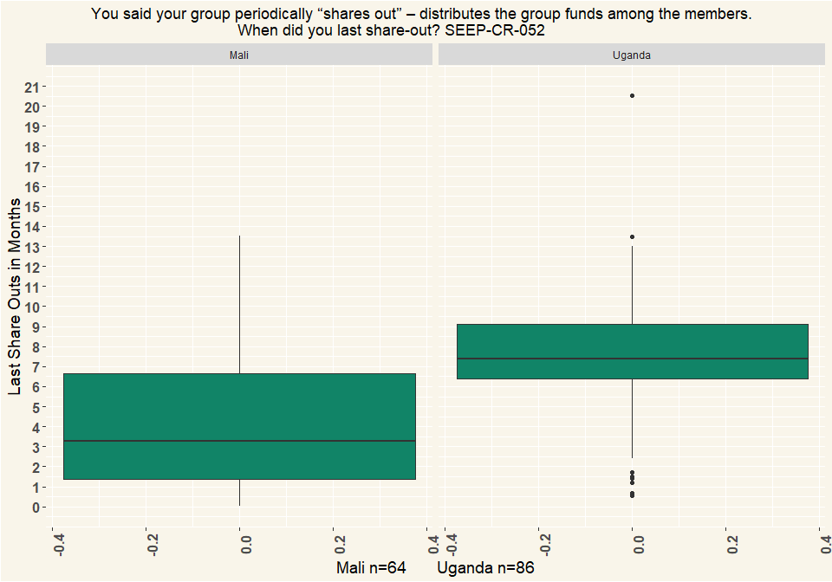

# Q53 Did someone help the group at last share-out?

|  |  |  |
| --- | --- | --- |
| Ideas | Mali | Uganda |
| Yes | 8 | 45 |
| No | 60 | 50 |
| Respondents | 68 | 95 |

# Q54 Who provided help at last share-out?

|  |  |  |
| --- | --- | --- |
| Assistance | Mali | Uganda |
| Volunteer or Village Agent or Replicator | 5 | 27 |
| Another group | NA | 1 |
| NGO or CBO | 1 | 6 |
| Other (specify) | 2 | 9 |
| None | NA | 2 |
| Respondents | 8 | 45 |

# Q55 Do you or anyone in your group know how to calculate the share out so that each person gets the right amount?

|  |  |  |
| --- | --- | --- |
| Calc_Skills | Mali | Uganda |
| Yes | 55 | 73 |
| No | 13 | 12 |
| I don’t know | NA | 10 |
| Respondents | 68 | 95 |

# Q57 Why don’t more members know how to calculate the share-out?

|  |  |  |
| --- | --- | --- |
| Reason | Mali | Uganda |
| They don’t need to, we have enough, we are happy the way it is | 3 | 1 |
| They are not educated or literate | 9 | 8 |
| No one has shown us | 3 | 3 |
| Other: | 1 | 1 |
| Respondents | 16 | 13 |

# Q58 The most recent time you shared out, did all the members receive the amount they expected?

|  |  |  |
| --- | --- | --- |
| Expectations | Mali | Uganda |
| quite some members had issues with the share out amount, it was less than expected | 50 | 69 |
| all were disappointed with the share-out amount | NA | 6 |
| Respondents | 50 | 75 |

# Q59 What caused the amount to be lower than expected?

|  |  |  |
| --- | --- | --- |
| Cause | Mali | Uganda |
| We lost money from late loans | 2 | 7 |
| We lost money from external theft | NA | 1 |
| We lost money but we don’t know how | 1 | 4 |
| Some members were suspicious or they are never happy | NA | 2 |
| Don’t know | 1 | NA |
| Other (specify) | NA | 1 |
| Respondents | 4 | 15 |

# Q60 How is the share-out calculated?

|  |  |  |
| --- | --- | --- |
| Calculated | Mali | Uganda |
| Everybody gets back what they saved and paid (interest paid on loans goes back to the person paying) | 19 | 9 |
| Everybody gets their saving back and the remainder split equally amongst the members | 13 | 7 |
| Everybody gets their savings back and the interest is distributed proportionately | 16 | 53 |
| All the money is split up evenly among all the members regardless of how they have saved. | 1 | 2 |
| Everybody gets an exact share according to participation (1, 2 or 3 ‘mains’) | 3 | 1 |
| I don’t know | 1 | 4 |
| Respondents | 53 | 76 |

# 63 Thank you. To follow up on what you said, I’m going to read some different categories of person. For each, please tell me whether they could be a member of your group?

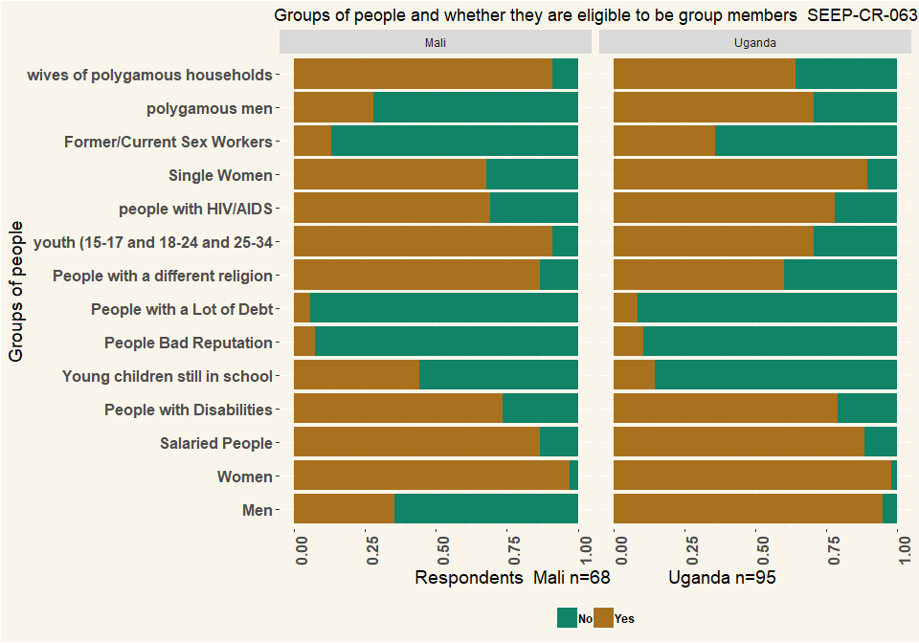

# 65 Does the VSLA group have any joint economic activity?

|  |  |  |
| --- | --- | --- |
| Activity | Mali | Uganda |
| Yes | 18 | 10 |
| No | 50 | 83 |
| I don’t know | NA | 1 |
| Respondents | 68 | 94 |

# Q66 If so, please describe what these joint economic activities are?

|  |  |  |
| --- | --- | --- |
| Activity | Mali | Uganda |
| Joint production | 13 | 5 |
| Bulk purchases of inputs | 4 | 1 |
| Bulk selling/Joint marketing of output | 5 | NA |
| Group business | 1 | 4 |
| Other (specify) | 3 | 3 |
| Respondents | 26 | 13 |

# Q67. does the whole group do participate in {0} or only some of the members?

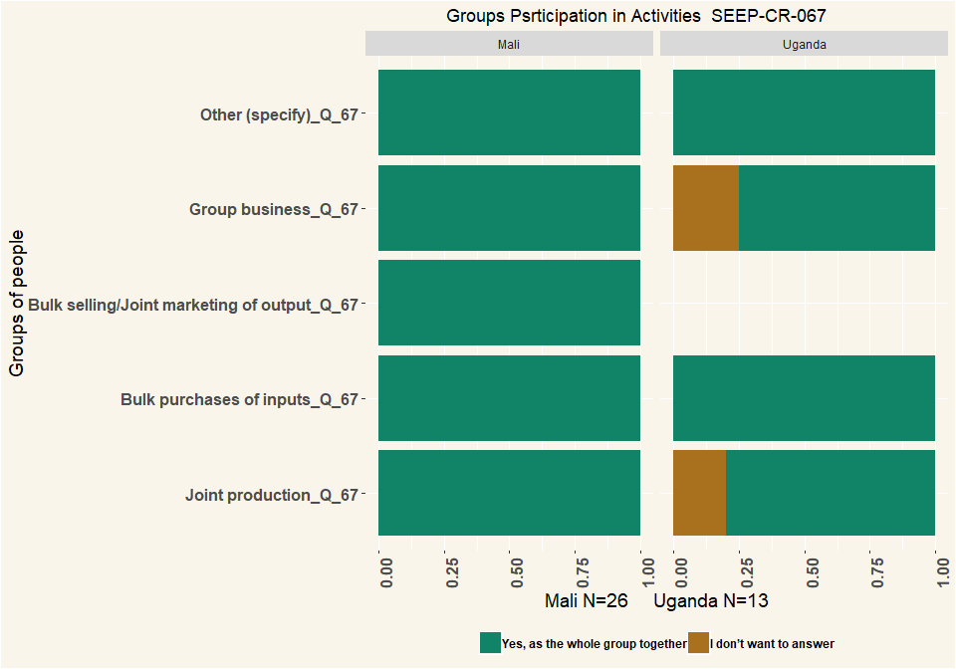

|  |  |  |
| --- | --- | --- |
| Activity | Mali | Uganda |
| Yes, as the whole group together | 26 | 11 |
| I don’t want to answer | NA | 2 |
| Respondents | 26 | 13 |

# Q68 Do the members trade with each other / provide each other business / refer customers to each other?

|  |  |  |
| --- | --- | --- |
| Trade | Mali | Uganda |
| Yes | 23 | 35 |
| No | 45 | 57 |
| I don’t know | NA | 2 |
| I don’t want to answer | NA | 1 |
| Respondents | 68 | 95 |

# Q69 Does your group have any relationship(s) with the following types of organisations?

|  |  |  |
| --- | --- | --- |
| Relation | Mali | Uganda |
| NGOs | 1 | 24 |
| CBOs | NA | 6 |
| Government agencies | NA | 3 |
| Religious institutions (mosque, church, …) | NA | 5 |
| Political party | 2 | 4 |
| Private company | NA | 5 |
| None | 65 | 59 |
| Does not want to answer | NA | 2 |
| Respondents | 68 | 95 |

# Q70 What type of relationship exist with organisation {0} ?

|  |  |  |
| --- | --- | --- |
| Relation | Mali | Uganda |
| Just contact (information exchange) | 1 | 27 |
| They supervise us | NA | 23 |
| They advise us / awareness raising | 1 | 23 |
| They give us training | 2 | 28 |
| They sell to us | NA | 1 |
| They help us with selling/finding clients | 1 | 1 |
| They give us money | NA | 1 |
| They give us loans | NA | 2 |
| They do research/ data collection | NA | 1 |
| Other (specify) | NA | 2 |
| Respondents | 68 | 95 |

# Q72 How satisfied are you with this relationship with the organisation {0} ?

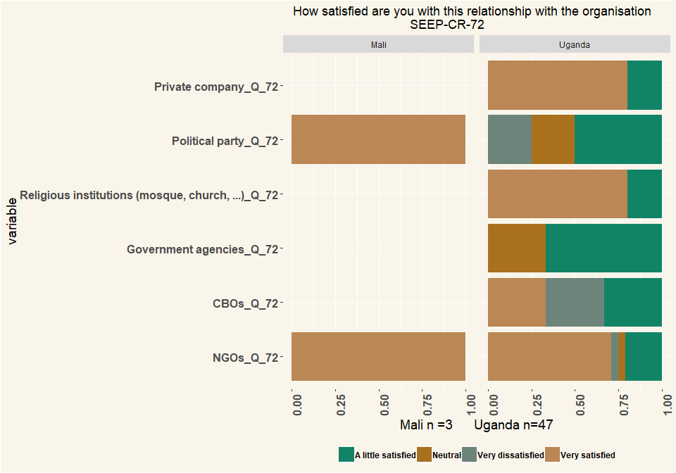

# Q73 Does the group have a relationship with a financial service provider?

|  |  |  |
| --- | --- | --- |
| Relation | Mali | Uganda |
| Yes, as a group | 4 | 20 |
| Yes, but individual members | 5 | 18 |
| No, nobody has any relationship | 58 | 47 |
| I don’t know | 1 | 10 |
| Respondents | 68 | 95 |

# Q74 What type(s) of relationship does the group have with a financial service provider?

|  |  |  |
| --- | --- | --- |
| Value | Mali | Uganda |
| Individual group members have accounts (unrelated to the group) | 5 | 27 |
| Individual group members have loans (unrelated to the group, group not guaranteeing loan) | 4 | 13 |
| Individual group members have accounts as a result of the group | 1 | 1 |
| Individual group members have loans, related to the group, group guaranteeing loan or member’s track record helping to get the loan | NA | 2 |
| Group has an account (e.g. for excess funds) | 3 | 16 |
| Group has a loan from financial service provider | NA | 5 |
| I don’t know | 1 | 1 |
| Respondents | 14 | 65 |

# Q75 In what type of institution(s) does the group have an account?

|  |  |  |
| --- | --- | --- |
| Value | Mali | Uganda |
| Commercial Bank | 1 | 6 |
| MFIs | 3 | NA |
| SACCOs | NA | 1 |
| Respondents | 4 | 7 |

# Q76 How did the group obtain its account?

|  |  |  |
| --- | --- | --- |
| Account | Mali | Uganda |
| Entirely group’s initiative/idea | 3 | 5 |
| Due to information from outside entity | NA | 1 |
| Suggested by outside entity | NA | 1 |
| Respondents | 3 | 7 |

# Q80 Is the group registered with any local authority? E.g. with the municipality, ministry of cooperatives, chamber of commerce, etc.

|  |  |  |
| --- | --- | --- |
| Register | Mali | Uganda |
| Yes | 18 | 49 |
| No | 47 | 44 |
| I don’t know | 3 | 1 |
| I don’t want to answer | NA | 1 |
| Respondents | 68 | 95 |

# Q81 Why is the group registered?

|  |  |  |
| --- | --- | --- |
| Register | Mali | Uganda |
| It is an obligation from the government | NA | 20 |
| We wanted to formalize our group / we wanted to register | 11 | 28 |
| We needed the registration for getting a bank account | NA | 1 |
| We needed the registration for something else | 7 | NA |
| Respondents | 18 | 49 |

# Q82 At which office did you register the group?

|  |  |  |
| --- | --- | --- |
| Office | Mali | Uganda |
| Department/Ministry of cooperatives | NA | 11 |
| Townhall | 18 | 4 |
| Mosque/church | NA | 1 |
| District | NA | 4 |
| Local council | NA | 1 |
| Sub-County | NA | 28 |
| Village level | NA | 1 |
| Respondents | 18 | 50 |

# Q83 Did it cost any money to register?

|  |  |  |
| --- | --- | --- |
| Cost | Mali | Uganda |
| Yes | 15 | 45 |
| no | 3 | 3 |
| I don’t know | NA | 2 |
| Respondents | 18 | 50 |

# Q84 How much did the registration cost?

* UGX/Dollar = 0.00027
* Mali CFA Franc (XOF)/Dollar = 0.0017

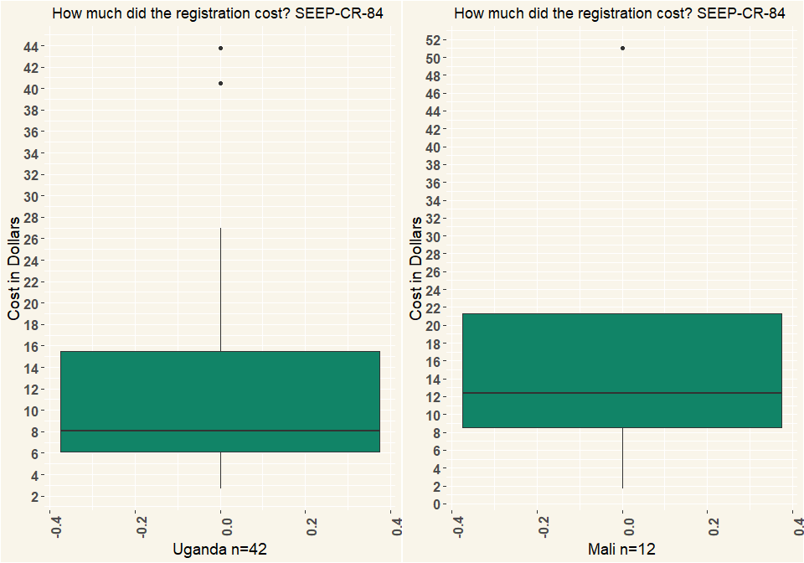

# Q85 What are the benefits of registration? (Multiple Choice)

|  |  |  |
| --- | --- | --- |
| Benefits | Mali | Uganda |
| Members take the group more seriously | 12 | 45 |
| Outsiders take the group more seriously | 18 | 33 |
| We can access support | 12 | 21 |
| We can open a bank-account | 2 | 11 |
| Other (specify) | NA | 1 |
| Respondents | 44 | 95 |

# Q86 Does the group use any form of technology? E.g. calculator on phone? an app on a phone to do bookkeeping?

|  |  |  |
| --- | --- | --- |
| Technology | Mali | Uganda |
| Yes | 10 | 88 |
| No | 58 | 7 |
| Respondents | 68 | 95 |

# Q87 What forms of technology does the group use?

|  |  |  |
| --- | --- | --- |
| Value | Mali | Uganda |
| Stand-alone calculator | 10 | 35 |
| Calculator on simple phone | 6 | 77 |
| Calculator on smart phone | 6 | 5 |
| Sending messages on simple phone | NA | 7 |
| Recording numbers or balances on simple phone | NA | 2 |
| Camera on simply phone | NA | 7 |
| Camera on smart phone | NA | 1 |
| Respondents | 22 | 95 |

# Q91 What is the gender of the respondent?

|  |  |  |
| --- | --- | --- |
| Gender | Mali | Uganda |
| Female | 68 | 61 |
| Male | NA | 34 |
| Respondents | 68 | 95 |

# Q92 Could you estimate the age of the respondent?

